https://dpeuniversity.gradle.com/courses/012de84f-fcd3-45d4-9c4c-284382eb3f3f/activities/92d9a305-980d-4e11-bc19-2de7076c6bb9

Gradle Wrapper – 3:20 minute

Here you will learn how to interact with tasks using the Gradle Wrapper.

So one of the goals of Gradle build tool is your enable teams to have consistent and reproducible builds, there are several factors that go into making builds consistent and reproducible, one of them is ensuring that everyone is using the same and correct version of the build tool itself. Different features may be available in different Gradle build tool versions, and though Gradle aims to be backward compatible between versions, the behavior of tasks may also slightly differ from one version to another version. So using the correct version is important. Also, you may work on five different projects that each require a different version of Gradle build tool. Having all five versions installed and then switching each turn you work on a different project can get tedious and is error prone. The Gradle wrapper solves this problem. The idea is, instead of running the Gradle build tool binary of the correct version directly, you run a wrapper script which reads the project configuration that contains which version of Gradle build tool to use, and the wrapper script invokes that version of Gradle build tool.

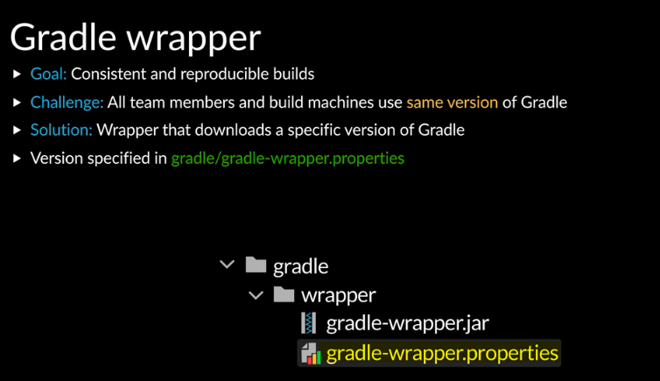

The version of Gradle build tool to use is configured in the Gradle wrapper, Gradle wrapper properties file.

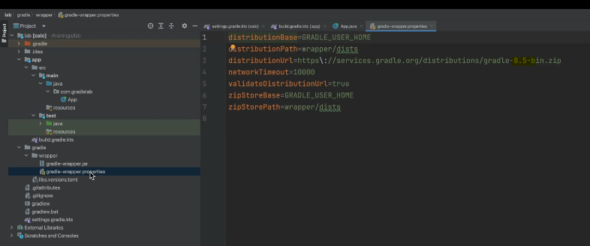

You can see here, version 8.5 is specified. There’s a string after the version, this specifies the distribution to use and can have two values; all and bin. The all distribution has the Gradle build tool binary along with the source code and some docs, the bin distribution has only the binary, so it’s smaller in size, therefore, it is recommended to use the binary distribution.

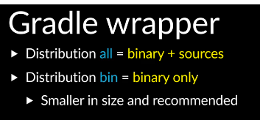

In the editor, you can open the terminal.

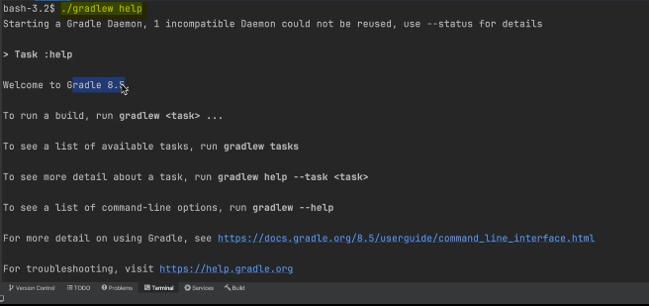

Here you can run a task using the wrapper, I will run the help task. You can see the version displayed in the output. On UNIX machines, you’ll run the Gradle w script, on windows machines, you will run the Gradle w batch file. p



When you’re on a task with the Gradle wrapper, it first reads the Gradle wrapper properties configuration and then looks for Gradle build tool off the version and distribution configured and ask it to run the task.

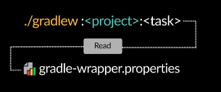

If it is unable to find the version of Gradle build tool, it downloads it first.

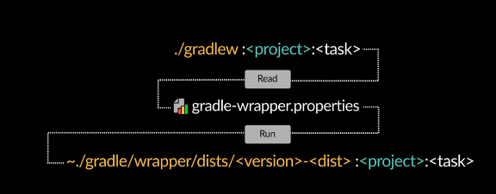

The wrapper will look for available versions in the Gradle home folder, wrapper dist directory. So even if you have the Gradle build tool binary installed elsewhere, if it doesn’t find it in dist directory, it will download it.

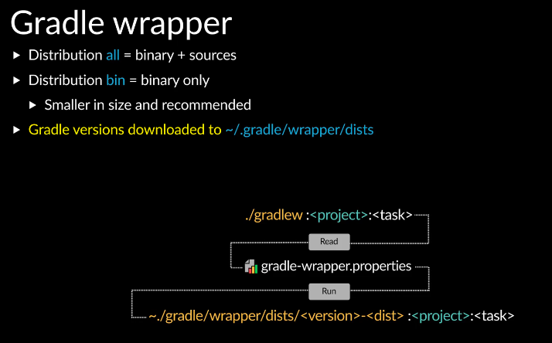

The wrapper configuration is checked into version control, so everyone working on the project will use the Gradle version of Gradle.

Completed…